AUTOMATIC FIRE EXTINGUISHER SYSTEM FOR
ELECTRIC VEHICLE CHARGING
STATIONS

Vasundharadevi R
Integrated M.tech Computer Science and Technology with specialization in Business Analytics
VIT Chennai
Chennai , TamilNadu
Jayaganesh
Integrated M.tech Computer Science and Technology with specialization in Business Analytics
VIT Chennai
Chennai , TamilNadu
K N Parthiv Rishi
Integrated M.tech Computer Science and Technology with specialization in Business Analytics
VIT Chennai
Chennai , TamilNadu

Abstract— As Electric Vehicles (EVs) gain popularity, there has also been a sudden increase in EV charging stations, which are crucial in s63
ustaining the transport systems. On the other hand, charging stations pose substantial fire hazards because of electrical faults, components overheating, short-circuiting, and battery failures. Fire at an EV charging station would damage property, threaten safety, and even endanger lives. Therefore, a solid fire-fighting mechanism will need to be established.
This project puts forth an Automatic Fire-Fighting System designed for EV charging stations capable of detecting, alerting, and extinguishing fires in real-time. It encompasses fire sensors, temperature sensors, a microcontroller (Arduino Mega), an automatic activation mechanism for suppression, and an interface for communication for enhanced safety. Once there is a fire detection, the system automatically activates an alarm system to turn off the power supply and commence the fire-fighting. It also sends alerts via GSM/Wi-Fi to related authorities, operators, and emergency responders for immediate intervention. This proposed intervention aims to provide cost-effective, reliable, and efficient fire hazard prevention in EV charging stations. This automated fire-fighting system will therefore go a long way in minimizing the damage by bringing down the risk of fires, damage to equipment, and loss of life, thus ensuring enhancement of safety and the flow of business operations.
- Keywords— Arduino MEGA, Electric Vehicle safety, battery failure, overcharging, Electric Vehicles, ABC powder.

I. Introduction

EVs have gained a lot of popularity with the worldwide transition towards clean energy and electric mobility and so have many EV charging stations. High-power station operations put them at risk from thermal runaways and electrical malpractice, but fire hazards are the worst put in. Unlike normal fires, EV-related fires are usually one of the most complicated ones since there exists high-voltage battery systems; even the appropriate methods of fire suppression would be counter-productive in containing or even extinguishing these fires.
The Automatic Fire Extinguisher System proposed here aims to proactively detect and suppress fires at EV charging stations, restricting them to a minimal incident in the first place. The system consists of highly advanced sensors for monitoring temperature variations, smoke and flame detection, and environmental monitoring. In case of any detected abnormality, the microcontroller processes the information to initiate immediate countermeasures, including:
- Activation of an alarm system to warn nearby persons.
- Shut down of power to prevent further electrical hazards.
- Discharge of fire-fighting agent like CO₂, Dry Chemical Powder, or Water Mist for extinguishment of the fire.
- Emergency alerts sent via GSM/Wi-Fi to inform the operators and fire safety personnel.
With IoT-based remote monitoring integrated into the system, real-time surveillance and data logging for early intervention and continuous safety evaluation are ensured. Thus, this fire risk mitigation approach at an EV charging station will contribute to making the infrastructure much safer and more resilient.

II. Literature Review
- A Review on IoT-Based Fire Safety Management Systems
An overview of how IoT technologies are at the heart of an automatic fire detection and emergency response system. Temperature, smoke, and flame sensors are engaged to facilitate real-time cloud alerts, reducing human effort and boosting reaction time. A mobile application-based remote monitoring makes the system safer, although limitations of network dependence and cybersecurity exist. Such systems, nevertheless, promise the advancement of operation efficiency and reliability in terms of IoT fire safety.
- A Review on Electric Vehicle Fire Extinguishing Systems

This overview discusses fire suppression technologies directed at EV fires. These fires pose specific challenges, such as the role of high-voltage batteries and thermal runaway. Agents such as CO₂, Dry Chemical Powder, and Water Mist are used to suppress battery fires and cool them down. These systems are integrated with state-of-the-art sensors with IoT alerts for automated response and remote monitoring. However, despite the safety improved, re-ignition can occur, which is an indication that more specialized infrastructure and innovations are still to be carried out.

- IoT-Based Fire Detection System with Automatic and Manual Extinguishing System

An overview of IoT-supported fire detection systems for both automatic and manual suppression mechanisms. Temperature, smoke, and flame sensors signal detection of fire and the deployment of agents such as CO₂ and Water Mist. IoT connectivity provides means for remote monitoring and alert notification through GSM and Wi-Fi channels for instantaneous response. Although they are effective and efficient, reduced human dependency, they still face challenges of network reliability and power consumption.

- IoT and CNN Based Fire Detection and Prevention

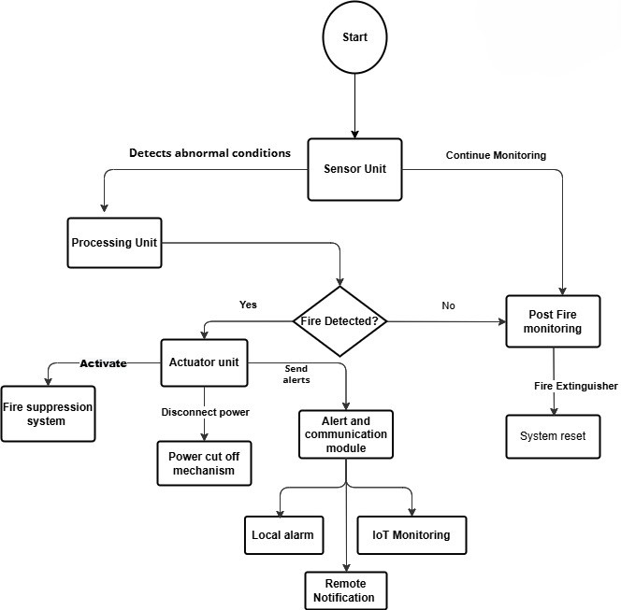
An overview that connects IoT and CNN for real-time detection and prevention of fire. It defines sensors for capturing data via the IoT network. CNN models then analyze the image and video to improve accuracy and reduce false alarms. Automated alerts, remote supervision, and fast emergency response using cloud and mobile apps are also part of the system. However, in spite of the many advantages earned by the system, it still has some issues for future optimization such as computational load and dependency in the network.

- Approaches to Mitigate Electric Vehicle Fire Risks in Enclosed Spaces
This overview summarizes the strategies available to reduce the risk of fires involving EVs in enclosed spaces such as parking garages and charging stations. Examples of key mechanisms include advanced suppression agents (CO₂, dry powder, water mist), better ventilation, and early detection using temperature and gas sensors. Complementing these are structural fire safety measures that include fire-resistant materials and designed zones for EVs. Although these methods improve response and prevention, continued investigation is needed to minimize risks for re-ignition and to further refine methods.
- Recognition of IoT-based fire-detection system fire-signal patterns applying fuzzy logic

This overview illustrates how to fine-tune fuzzy logic to increase the performance of IoT-based fire detection systems. An ordinary by assembly line seldom avoids false alarm alerts caused by fluctuations in sensing devices, while fuzzy logic will effectively make a decision based on identifying fire-signal patterns emitted from temperature, smoke, and gas data. This connectivity with the help of IoT offers real-time monitoring, automated alerts, and remote response. Further studies are therefore needed, given that this nature improves adaptability and precision in detection but nonetheless presents drawbacks like computational complexity and system optimization.

- An IoT-based Fire Safety Management System for Educational Buildings: A Case Study
This summary brings us to the possible IoT-based solutions in fire safety management for educational institutions, where this would be a timely intervention into early detection and emergency response. The system embodies temperature, smoke, and flame sensors interfaced into the cloud dashboards and mobile applications to perform real-time monitoring and alerting. With all these features, safety is actually enhanced with the aspect of fast intervention. However, areas like scalability, network dependency, cybersecurity, and power efficiency are left out in further development.

III. Archiecture Diagram

The Automatic Fire Extinguisher System for EV charging stations consists of multiple interconnected components designed to detect and suppress fire hazards efficiently. The system architecture is structured into the following functional blocks:
3.1 Sensor Unit
The sensor unit continuously monitors environmental conditions to detect potential fire hazards. It includes
a. Temperature Sensors: Detect abnormal heat levels indicating potential overheating.
b. Flame Sensors: Identify the presence of open flames.
c. Smoke Detectors: Detect smoke or toxic fumes generated during electrical or battery-related fires.
3.2 Processing Unit (Microcontroller)
The system employs an Arduino microcontroller, which processes real-time sensor data and determines whether to activate the fire extinguisher system. The microcontroller evaluates sensor readings, filters out false alarms, and triggers emergency responses if a fire is confirmed.
3.3 Actuator Unit
Once a fire is detected, the actuator unit activates suppression mechanisms. The key components include:
a. Solenoid Valves: Control the release of the fire suppression agent.
b. Fire Extinguisher System: Deploys CO₂, Dry Chemical Powder, or Water Mist to extinguish the fire.
c. Motorized Nozzles: Direct the extinguishing agent toward the fire source for targeted suppression.
  - Power Cut-off Mechanism
To prevent further electrical hazards and reduce the risk of fire escalation, the system incorporates a power relay module that automatically disconnects the power supply to the charging station upon fire detection.
a. Alert and Communication Module: For immediate response and remote monitoring, the system integrates multiple alert mechanisms, including:
b. Buzzer & LED Indicators: Provide local visual and auditory alarms for on-site awareness.
c. GSM/Wi-Fi Module: Sends alerts to station operators and emergency response teams via SMS or cloud-based notifications.
d. Mobile App or Cloud Dashboard: Enables remote monitoring of system status and fire events in real-time.
By integrating these functional components, the proposed system ensures rapid fire detection, efficient suppression, and real-time communication, significantly enhancing safety at EV charging stations.

Data Flow and System Operation
- System begins by continuously monitoring via the Sensor Unit.
- Detected abnormal data is passed to the Processing Unit.
- If fire is confirmed:
- Actuator Unit activates suppression system and cuts power.
- Alert Module sends notifications and triggers alarms.
- Data is also sent to the IoT Dashboard for real-time updates.
- If no fire is detected or post-suppression is complete, the Post-Fire Monitoring Unit ensures there’s no re-ignition.
- Once verified safe, the System is reset and continues monitoring.

IV. System Requirements

4.1 Hardware Requirements

The proposed system consists of various hardware components essential for fire detection, suppression, and alert mechanisms. The key hardware components are as follows:
Category | Component | Specification/Function
Microcontroller | Arduino Mega | Processes sensor input and controls actuators for fire response.
Flame Detection | Flame Sensor | Detects visible flame; triggers alert when threshold is breached.
Temperature Sensor | DHT11 / MLX90614 | Measures ambient temperature; identifies rapid heat increase.
Smoke Sensor | MQ-2 / MQ-135 | Detects smoke or harmful gases (CO, NH₃, Benzene, etc.).
Fire Suppression | Solenoid Valve | Controls release of suppression agents (CO₂, DCP, Water Mist).
 | Fire Extinguisher System | Mechanism to store and dispense suppression agents.
12+
Directional Control | Motorized Nozzles | Aims the extinguishing agent toward fire source precisely.
Alert System | Buzzer & LED Indicators | Emits sound and light signals during fire detection.
Communication Module | GSM / Wi-Fi Module | Sends alerts via SMS, app notifications, or cloud updates.
Power Control | Relay Module | Automatically disconnects charging power during fire event.

5.2 Software Requirements

The proposed system requires specific software tools and libraries for programming, real-time monitoring, and communication. The key software components are:
Category | Software | Specification/Function
Programming Platform | Arduino IDE | Develops and uploads control logic to the microcontroller.
Programming Language | Embedded C | Used for writing sensor logic, alert protocols, and control routines.
IoT Dashboard | Blynk / ThingsBoard | Provides real-time monitoring and visualization of fire events.
Communication Library | GSM / Wi-Fi Libraries | Supports SMS alerting and cloud communication.
Alert Integration | Cloud API / App Integration | Pushes data to mobile apps or web dashboards for immediate alerts.

V. RESULTS AND CONCLUSION

The implemented Automatic Fire-Fighting System for EV charging stations was tested under controlled conditions to evaluate its responsiveness, reliability, and overall effectiveness. The system consistently demonstrated accurate detection of fire-related anomalies through the integration of temperature, smoke, and flame sensors.

Upon confirmation of a fire event, the Arduino Mega microcontroller processed sensor data in real-time and initiated a sequence of safety actions, including the automatic activation of visual and auditory alarms, disconnection of the power supply to the charging station, and deployment of a fire suppression agent such as CO₂, Dry Chemical Powder, or Water Mist. Simultaneously, alerts were successfully transmitted to station operators and emergency responders through GSM and Wi-Fi modules, while real-time updates were made available via a cloud dashboard or mobile application.
1. Hardware:
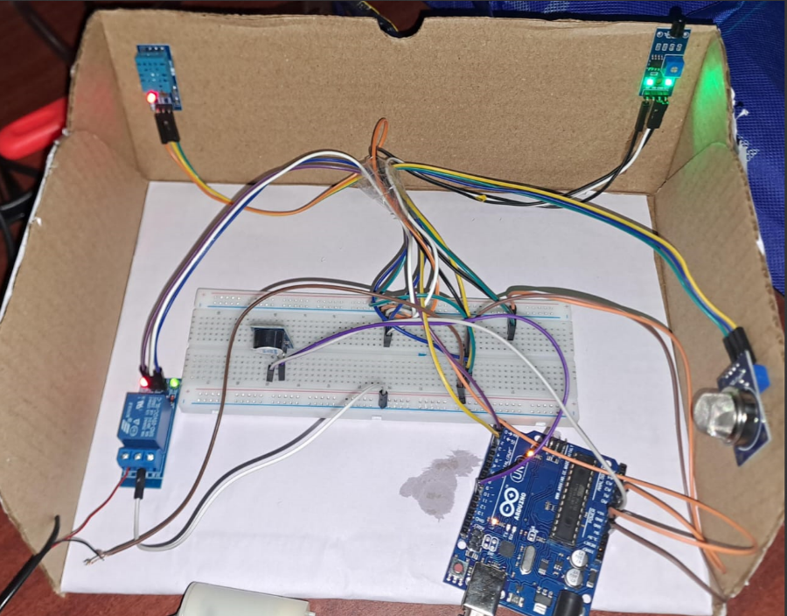

2. Software:

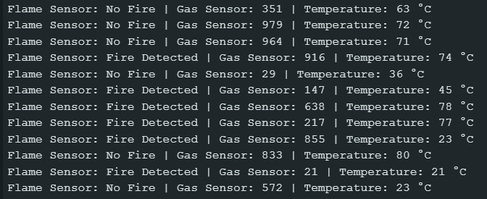

Throughout testing, the system achieved rapid response times with minimal latency, and the suppression mechanisms proved effective in extinguishing simulated fire scenarios, particularly small to medium-scale electrical fires. The communication and alert modules also maintained high reliability under standard network conditions. These results affirm the proposed system’s capability to provide a cost-effective, automated, and efficient fire prevention solution tailored to the specific challenges of EV charging stations. By minimizing human dependency and ensuring timely intervention, the system enhances overall safety and reduces the risk of equipment damage, financial losses, and potential casualties. This work underscores the importance of integrating IoT-based safety frameworks within high-risk infrastructure and opens avenues for future enhancements through AI-driven analytics, improved network resilience, and scalability across larger or more complex EV charging environments.

VI. CONCLUSION

The development and deployment of this automatic fire-fighting system demonstrate a viable and cost-effective solution for fire safety in EV charging infrastructure. By leveraging microcontroller-based control, IoT-enabled alert systems, and automated extinguishing mechanisms, the system significantly reduces the risks associated with battery malfunctions, overcharging, and thermal runaway events.
It ensures proactive safety, operational continuity, and reduced dependency on manual intervention during fire outbreaks. This approach lays the groundwork for scalable and intelligent fire prevention systems that can be customized for larger or more complex EV infrastructures. Future work may focus on expanding sensor fusion capabilities, enhancing network resilience, and incorporating AI-driven analytics to further reduce false alarms and improve system intelligence.

VII. References

[1] S. Kamel, A. Jamal, K. Omri, and M. Khayyat, "An IoT-based Fire Safety Management System for Educational Buildings: A Case Study," International Journal of Advanced Computer Science and Applications, vol. 13, no. 7, pp. 1–9, 2022.

[2] J. Orosz and T. Sebestyén, “Electric Vehicle Fire Extinguishing System,” Procedia Engineering, vol. 172, pp. 543–550, 2017.

[3] M. Rahman, S. Hossain, and T. Ahmed, “IoT-Based Fire Detection System with Automatic and Manual Extinguishing System,” International Journal of Engineering Research & Technology (IJERT), vol. 12, no. 5, pp. 102–108, 2023.

[4] S. Raghavendra, R. K. Sundareshwaran, and Y. V. Phaneesh, "IoT and CNN Based Fire Detection and Prevention," 2023 International Conference on Computing, Communication, and Security (ICCCS), pp. 1–5, 2023.

[5] International Council on Clean Transportation, “Approaches to Mitigate Electric Vehicle Fire Risks in Enclosed Spaces,” ICCT Report, Feb. 2024.

[6] S. H. Park, D. H. Kim, and S. C. Kim, "Recognition of
IoT-based fire-detection system fire-signal patterns applying fuzzy logic," Heliyon, vol. 9, no. 2, e12964, Feb. 2023.

[7] S. Kamel, A. Jamal, K. Omri, and M. Khayyat, "An IoT-based Fire Safety Management System for Educational Buildings: A Case Study," International Journal of Advanced Computer Science and Applications (IJACSA), vol. 13, no. 7, pp. 789–795, 2022.

